Assignment 5

**override functions of module in Node.js**

At first initialize create app.js file and initialize project then code the app.js

1. Then require the module which we want to override.
2. Then delete the function of the module which we want to override. Here we would override the format() function of ‘url‘ module
3. Now add the function with the same name ‘format‘ to provide a new definition

format() function of the module

1. Now re-export the ‘url‘ module for changes to take effect
2. Run the code

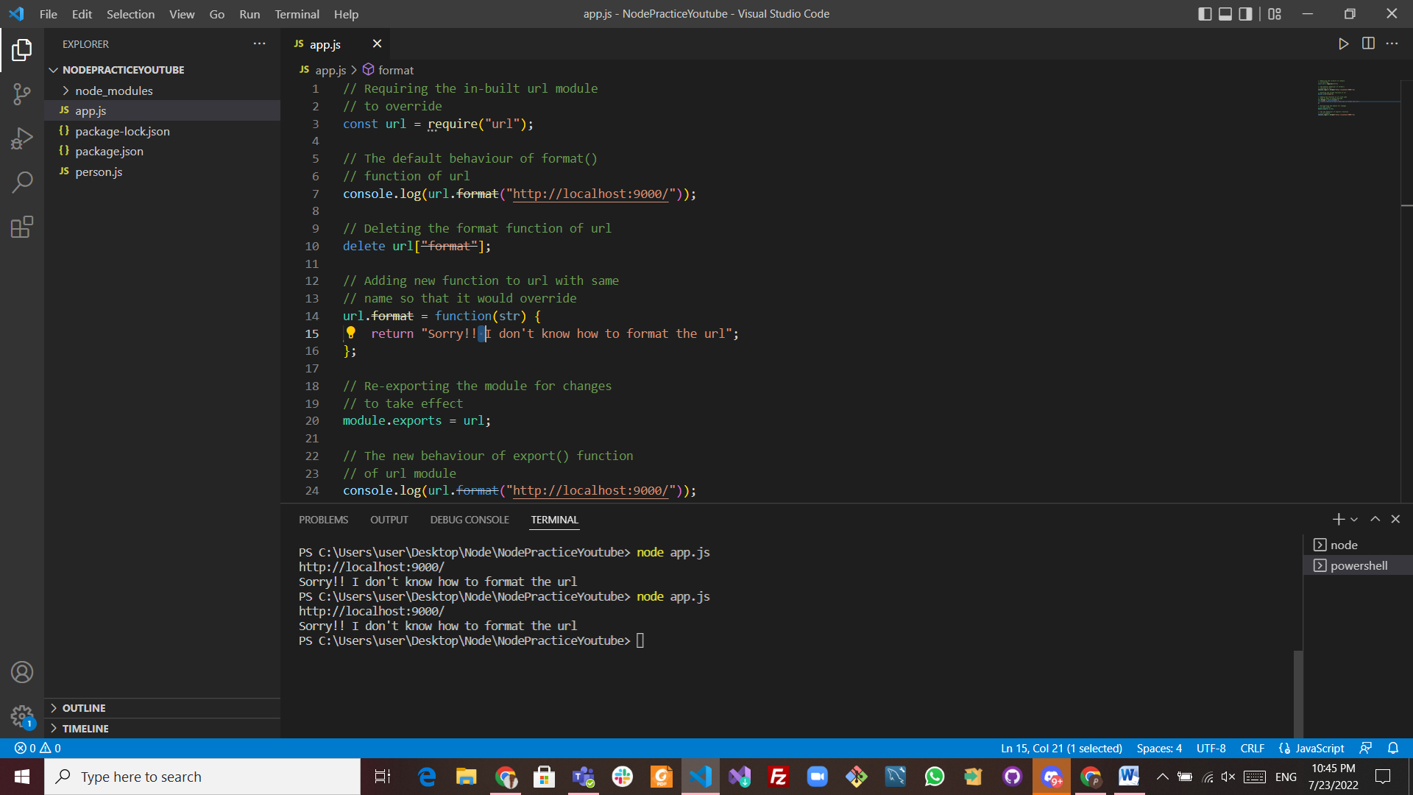

The link of github:

<https://github.com/MaremarSamara/Assignment5>